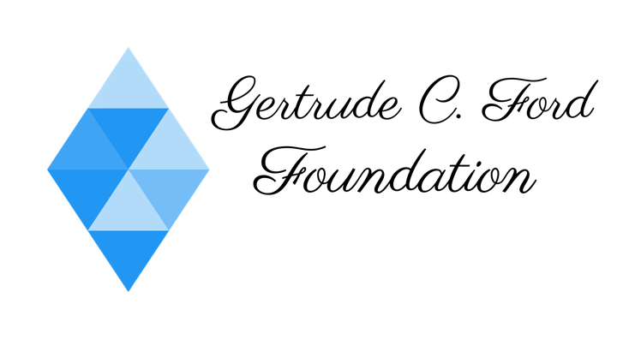

Grant Request Checklist

- 501(c)(3) Qualification Letter from the IRS
- Statement of Need
- Project Description
- Impact Statement
- Organization Operating Budget
- Project Budget
- Project Timeline

Dear Requestee,
Before a meeting with our directors can be scheduled, the above checklist needs to be completed and mailed or emailed to us. All requests can be addressed to Mrs. Cheryle M. Sims the President of the Foundation. Please mail all request to 199 Charmant Place, Suite 2, Ridgeland MS 39157 or email it to us at requests@gertrudecford.com.
Sincerely,
The Gertrude C. Ford Foundation

